RESUME

Ajay Kumar Sahani
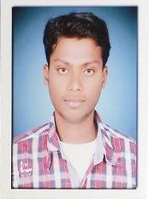
c\o-Mr. Premlal Chakrawarti Near railway gate ,bargi colony, shanti nagar Narsinghpur(M.P.)-487001
Contact no:9039147005
E-mail :-sahani4tillu@yahoo.in

PROFESSIONAL OBJECTIVE

To associate myself with an organization,where I can get an opportunity to contribute & update my knowledge & explore the potential, so that I can entail myself towards organizational growth.
ACADEMIC QUALIFICATION

Stream | Board/University Year of Passing | Result
Higher Secondary (PCM) | m.p board/2008 | 59%
High School | Bihar Board/2006 | 55%

ITI(ELECTRICIAN) | NCVT/2011 | 70%

PERSONAL PROFILE
Name Ajay kumar sahani Father’s Name Mr. Jagdish sahani
Date of Birth 24 JULY 1991
Communicable Languag English, Hindi.
Marital status Single
Contact no. 9039147005
Current CTC Fresher
Expected salary Negotiable.
Current location JABALPUR
Preferable location NARSINGHPUR
Nationality Indian
______________________________________________________________________

DECLARATION
I hereby declare that above mentioned information’s is best of my knowledge and I take the responsibility for correctness of above information’
Date:
Place Narsinghpur Ajay Kumar Sahani

